Snookie’s Society Foster Application

What does fostering a dog involve?
When you foster, you agree to take a homeless dog into your home and give him or her love, care and attention, either for a predetermined period of time or until the dog is adopted.
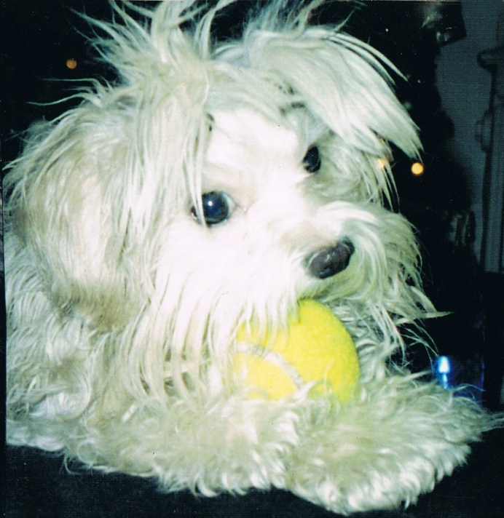

Why do adoption groups need foster homes?
There are many reasons a dog might need foster care. Some of the most common include:
- The rescue group doesn’t have a physical shelter and depends on foster homes to care for dogs until suitable homes are found. This can take an average of 3 weeks.
- A puppy is too young to be adopted and needs a safe place to stay until he or she is old enough to go to a forever home.
- A dog is recovering from surgery, illness or injury and needs a safe place to recuperate.
- A dog is showing signs of stress such as pacing or hiding in the shelter.
- A dog has not lived in a home before or has not had much contact with people and needs to be socialized (puppy mill dogs).
- The dog is showing behavioral issues and need guidance and training to set them in a better path to finding a forever home (a trainer/assistance is available in such a case).

Why should I foster a dog?
Fostering a dog is one of the most rewarding experiences you can have (other than adopting, of course). By taking an animal in need temporarily into your home you’re:
- freeing up a spot so the rescue can take in another dog from a pound.
- giving your foster dog the time he needs to be ready for adoption.
- helping the shelter or rescue learn more about the dog so he can end up in the best home possible. A write up, description and pictures are given to the rescue so they can advertise and match the dog up the best way possible.
- socializing the dog to a home environment and possibly getting him used to being around other pets and different types of people and situations.
What else do I need to know about fostering?
- Snookie’s Society will be responsible for any medical, training assistance or equipment (harness, citronella collar...) or other approved expenses associated with the foster dog in my care. Please check with representative as we often have additional supplies that we can pass along. Please see foster application for further detail and information regarding this.
- The foster home agrees to provide high quality food for the foster dog at their own expense. Treats, toys, beds etc…. Is also the responsibility of the foster home. The Rescue will try to help with these incidentals wherever possible. We do receive food donations but sometimes depending where you are located, it is geographically difficult to be able to drop off and pick up food for each foster home all across Ontario.
- Commit in keeping the foster dog in your care until s/he has found a forever home. We understand that sometimes a volunteer’s situation can change but please look ahead if you are planning a holiday or starting a new contract before taking on the responsibility and not being able to follow through. We will always try as much as possible to match you up appropriately to the new foster dog. We ask an average of 3 to 4 weeks of foster time. This also depends on the adoptability of the dog in your care.
- Training equipment consists of: Martingale, Ruffwear Webmaster harness, 2 leashes and a cliplead. If foster families are unable to purchase this ahead of time, (we refund the purchase), we can order ahead for you. If you are a foster to adopt, please purchase the items and if the dogs ends up being placed for adoption, the adopter buys the equipment from you. If you adopt the dog, the equipment becomes a purchase for your own dog.
- If your dog requires a GPS collar, Snookie’s Society will provide this ahead of time. You will need to download the app associated to the GPS collar.
- Snookie’s invest on medical treatment and training. 95% of the time, all medical care to prepare the dog for adoption is done PRIOR to you receiving your foster dog.
- There is a mandatory training process with Snookie’s Society. We cover many areas from general dog care to positive training and preventing runaway dogs. All our trainers and behaviorists are certified. This is done prior to you receiving one of our dogs.
What are we looking for?
When it comes to foster families, we look for experience. A lot of times, as many questions as we ask and try to find out about our dogs, sometimes there’s behaviors and other issues that do require rescue dog experience. For this reason, we hope to find a foster home who is able to handle “surprises”. Rescue dog experience comes in handy when it comes to training and re-socializing dogs.
With experienced foster homes, we can teach them to evaluate the dog and do basic SAFER test assessments. The learning curve is quicker and we can provide training.
There are times we have people with established dog experience but no rescue dog experience. Matching you up properly comes down to which dog you are interested in and if the dog is a suitable for your experience level. Having dog experience goes a long way and depending on the dog, we can provide training to bring you up to speed. Even though some things will be foreign to you, we do have trainers who can support you.
First time dog owners, we are unable to place a foster dog in your home. Not that you can’t learn as you go! The problem is that we are often on a time crunch, pressured to rescue a dog in need or if the dog is in a urgent situation slated for euthanasia. Training at this point cannot be in place as it will take time and we have no time! For this reason, we are looking for dog/rescue dog experience ready to go from our foster homes.
How do I sign up to foster a dog?
Please contact us at info@snookiessociety.com or send this form back to us by email. We ask that you fill out the foster application and, if you are approved (application, reference check and home check), we will work with you to figure out the right foster dog for your household and you go from there! Foster to adopt is available as well. Please return the application if you would like to begin!

FOSTER HOME APPLICATION

We ask that you please consider each question carefully as the information you provide assists us in assessing the type of dog we can place in your care.

PERSONAL INFORMATION:

Today’s Date: ______________________________________________________
Name: ______________________________________________________________________
Street: _______________________________________________________
City: ________________________ Province: _________ Postal Code: _______
Home Telephone: _______________ Work Telephone: _____________________
Employer: ______________________________________ May we contact you at work?_____________
Email Address: ______ __________________________________

Are you fostering a dog with the intent of possibly adopting the dog or are you applying strictly as a volunteer foster home with no intentions of adding another pet in the home permanently? _____________

Please indicate yes or no as we require notice ahead of time if this dog is placed with the intentions of adoption. If you are fostering with hopes of adopting, you are called a foster to adopt applicant. Not a foster home applicant. Foster to adopt applicant will need to be screened in the same way an adoption applicant would be. Fostering to Adopt does not guarantee the dog will be placed in your home. It has to be a mutual agreement between both parties.

Foster to adopt families are given a maximum of 15 days to decided whether or not they wish to adopt the foster dog in their care. It would be good to know as soon as possible whether or not you wish to adopt the foster dog. If you do not wish to adopt your foster to adopt dog once in your care, we will place the dog up for adoption. When the dog is listed online as available for adoption, you are no longer able to adopt your foster to adopt dog. However, you can help us choose a suitable family for the dog.

Canada Adoption Fees:
Our adoption fee for a LOCAL PUPPY is 795.00
Our adoption fee for a LOCAL ADULT DOG is 750.00 (1+)
Our adoption fee for a LOCAL SENIOR DOG is 495.00 (12+)
Our adoption fee for an INTERNATIONAL PUPPY (under 12 months) is between 895.00-1250.00
Our adoption fee for an INTERNATIONAL ADULT DOG (12 months and up) is between 850.00-1200.00
Our rescue pets have their basic DHPP and RABIES vaccination done. They are examined by a vet, dewormed, neutered/spayed, microchipped and temperament evaluated prior to being adopted. Our pets are heartworm tested prior to adoption (Depending on the season and location where the dogs are rescued from). All medical documents are provided to the successful applicant prior to the adoption. We do our best to ensure they are healthy. We are not responsible for teeth cleaning or regular dental procedures.
We do try to care for our rescue dogs teeth when funds are available to us.

Unforeseen illnesses can happen, and because of this, the dog’s health cannot be guaranteed.

With international dogs, we do the same medical procedures as the above local dogs but with added screening and treatments. Our international dogs are tested for Corona Virus, Leishmaniasis testing and 6 bone vector disease testing. In addition, we run a complete CBC blood profile, antibody titer testing and full local and foreign parasitology testing.

Snookie’s Society can only inform the applicant on the current health and temperament of this dog. No one can predict what medical or temperament problems a dog may have in its lifetime.

COMPANION ANIMAL INFORMATION AND HISTORY:

Have you had pets in the past? If so, please describe.

Do you have pets currently?

Please list pets you currently have in your home. Include the following information in your list. Type/Breed; sex; age; owned since; comments on personality of each animal. Please attach an extra sheet if needed.

Are your pets spayed/neutered? If no, please explain.

What are your personal beliefs on spaying and neutering?

Are your pets up-to-date on vaccinations and heartworm tests/preventative?

*The name and phone number of your veterinarian are mandatory*

Veterinarian’s Name:
Address:
Telephone Number:

How long have you been associated with this vet and/or clinic?
Would your pets accept a new dog?
Where are your pets kept during the day or when no one is at home?
Where do your pets eat?
Where do your pets sleep?
Where are your pets when you are at home? .
If you travel, what arrangements do you make for the care of your pets?

HOUSING INFORMATION:

Do you own __ ______ or rent _________, a house ________, ________ or condo _________?

*If renting, please provide landlord’s name, address and telephone number. We require written consent stating that you are permitted to have a foster dog on the premises. Please include this consent with your completed application*

Landlord’s name:
Address:
Telephone:

Snookie’s Society has a total restraint policy. Do you have a securely fenced yard?
What type of fencing? (Please describe in terms of material and height)

If you don’t have a fence, are you willing to fence, install an exercise run or leash walk at all times? Please indicate which of the above would apply to you.

YOUR FAMILY
How many adults are in your home? ________ Children? ________

Names and ages of people living in your home:
Is everyone living in your home agreeable to having a foster dog?
Do other children visit your home?
How would you describe the activity level of your household? i.e. quiet, structured, busy, hectic etc….
What are the working hours of the adults in the household?
Who would care for the foster dog when the adult(s) are not home?
We do not place foster dogs in homes with children under 12 years of age. If there is a child visiting the home who is under 12 years of age, would you provide constant supervision of the child/dog and never leave them unattended together?
Does anyone in your home have allergies? Please describe.

THE FOSTER DOG

** Dogs vary greatly in temperament, personality and activity level. Please keep this in mind as you fill out this section and provide us with as much information as possible and carefully consider your answers

Have you ever owned/lived with a RESCUE dog before?

What would you do if a dog bit you? Please describe.

What characteristics would you use to describe in the breed of dog that you are interested in?

What characteristics would you find desirable in your foster dog?

What characteristics would you find undesirable in a foster dog?

Would you accept a dog that is:
Older?
Has been abused?
Not reliable with children?
Has behavioural issues?
Partly or not housetrained?
Has physical disabilities/handicaps? Has separation anxiety?
Exhibits fear aggression?
Is pregnant or whelping?
Has dominance issues?
Has a strong prey drive?
Is recovering from a medical condition?

How long would you expect your fostering term for any one dog to last?
Would you be willing to foster the dog until a permanent home is found?

Many rescue dogs have problems with fearfulness, fear aggression, separation anxiety and housetraining to name a few. Would you be willing to help retrain a dog following a specific behavioural remediation program that included support from a trained professional?

If necessary, would you be willing to take a foster dog to obedience training?
Have you ever housebroken a puppy or dog?
How would you approach housebreaking a dog? Please explain in detail.

What forms of discipline do you feel are appropriate for training or modifying behaviour in a dog?

Would you be willing to transport a foster dog to veterinarian appointments?

Comments or Questions? Please feel free to include any information that you feel we should know about you, your family, and your experience with pets. Also include any concerns or questions you may have regarding fostering or our organization.

REFERENCES:

Please provide us with three references in addition to your vet. We are looking for individuals who can provide us with information about your suitability as a foster home.

Please provide full name, telephone number(s) and relationship for all references

Reference #1

Reference #2

Reference #3

By signing this document:

I understand that Snookie’s Society will be responsible for any medical, training or other approved expenses associated with the foster dog in my care. Note: If injuries or medical treatment is required as a result of negligence on the part of the foster parent (foster home) or during the time period the say dog is in the care of the foster home; the foster home will be held responsible for covering the costs of all treatment.

I understand that by signing this form I agree to release and covenant to hold harmless Snookie’s Society, and its members from any claims, damages, costs, or actions incurred as a result of the foster care or actions of the foster dog.

I will notify Snookie’s Society immediately should the foster dog become lost, stolen, ill or die.

If there is a biting incident, foster home must notify rescue first before taking any further actions or make any decisions on their own.

I agree to contact my Snookie’s Society representative at least twice per week to update her/him on the condition and well-being of the foster dog.

Snookie’s Society strongly discourages training or behaviour modification through physical violence of any sort. We will not condone nor tolerate hitting, ‘spanking’ or any other form of physical punishment. All foster dogs must wear an I.D. collar with the foster’s home telephone number and the telephone number of your Snookie’s Society Representative at all times. The foster home agrees to provide high quality food for the foster dog at their own expense. Treats, toys, beds etc…. Is also the responsibility of the foster home. The Rescue will try to help with these incidentals wherever possible.

Please keep the dog on leash at all times. If you are bringing the foster dog to a fully fenced dog park, please make sure it’s only for small breed dogs. Do not bring the foster dog to an all breed dog park. It must be a size appropriate dog run.

When traveling in a car, the foster dog must be constrained (seat belt or crate) and never left to roam in the car.

Snookie’s Society reserves the right to perform visits to the foster homes.

Snookie’s Society reserves the right to take the dog off the premises at any time.

Note: If Snookie’s Society judges the foster dog to be in danger, this signed (electronic) document releases Snookie’s Society to remove the dog from said premises without warning.

The foster home understands that Snookie’s Society cannot predict the behaviour of any dog in any situation. Snookie’s Society will provide any relevant information on the dog’s history and temperament that is known. This information may or may not be a reliable indicator of how the dog will behave in a new environment; including your home.

I certify that I am at least 18 years of age and that I will be solely responsible for the care and well-being of any dog that I foster for Snookie’s Society. Any misrepresentation of the true facts in this application will invalidate the foster home agreement and will give Snookie’s Society the right to immediately reclaim the foster dog.

Sending this application constitutes an electronic signature and legally binding.

Signature __ __________________________________ Date ______________________

Witness ___________ ________________________ Date ______________________

